**Sachin Sirohi**

**How to Download and Install JMeter for Windows?**

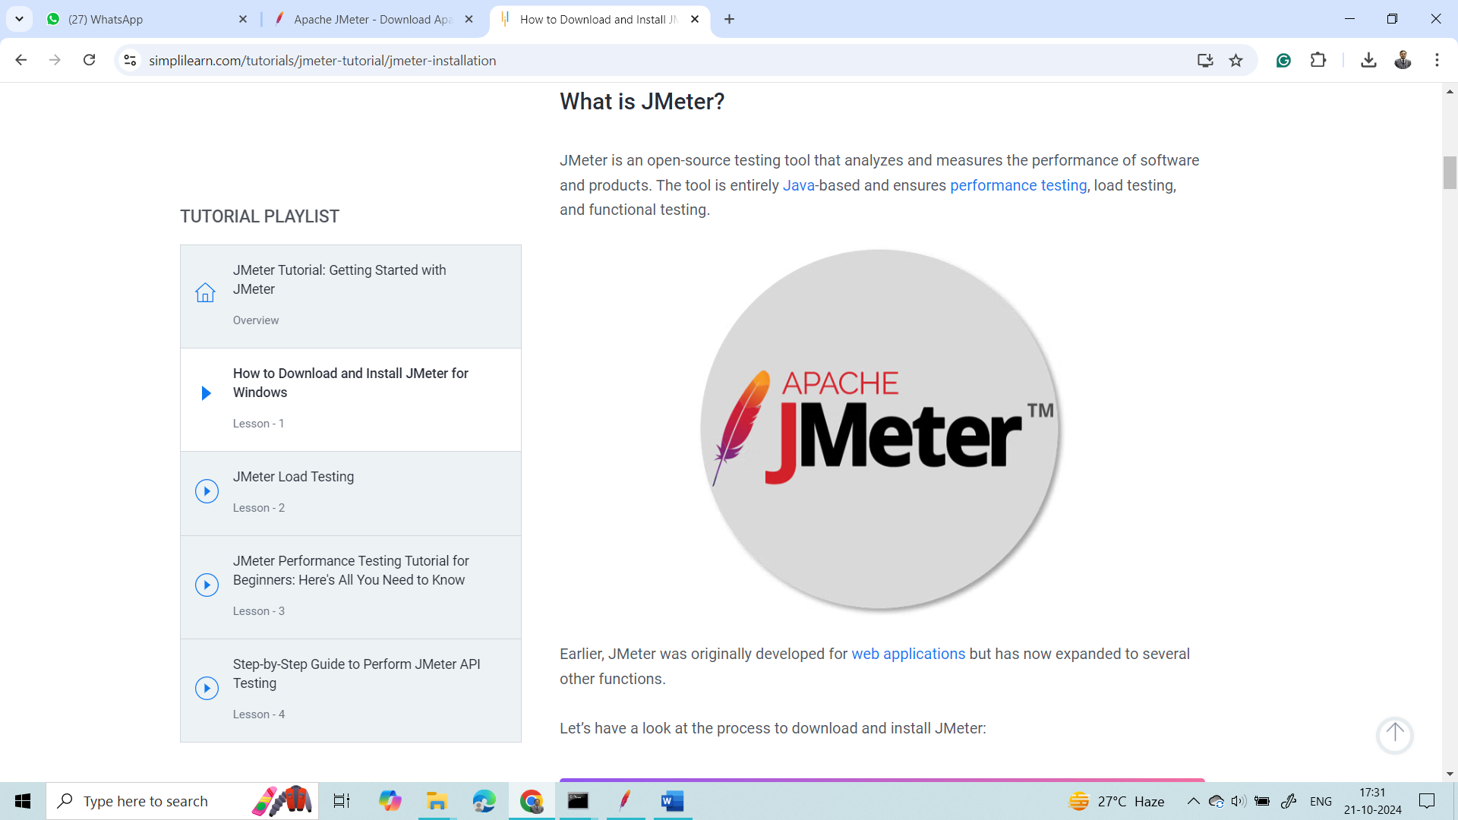

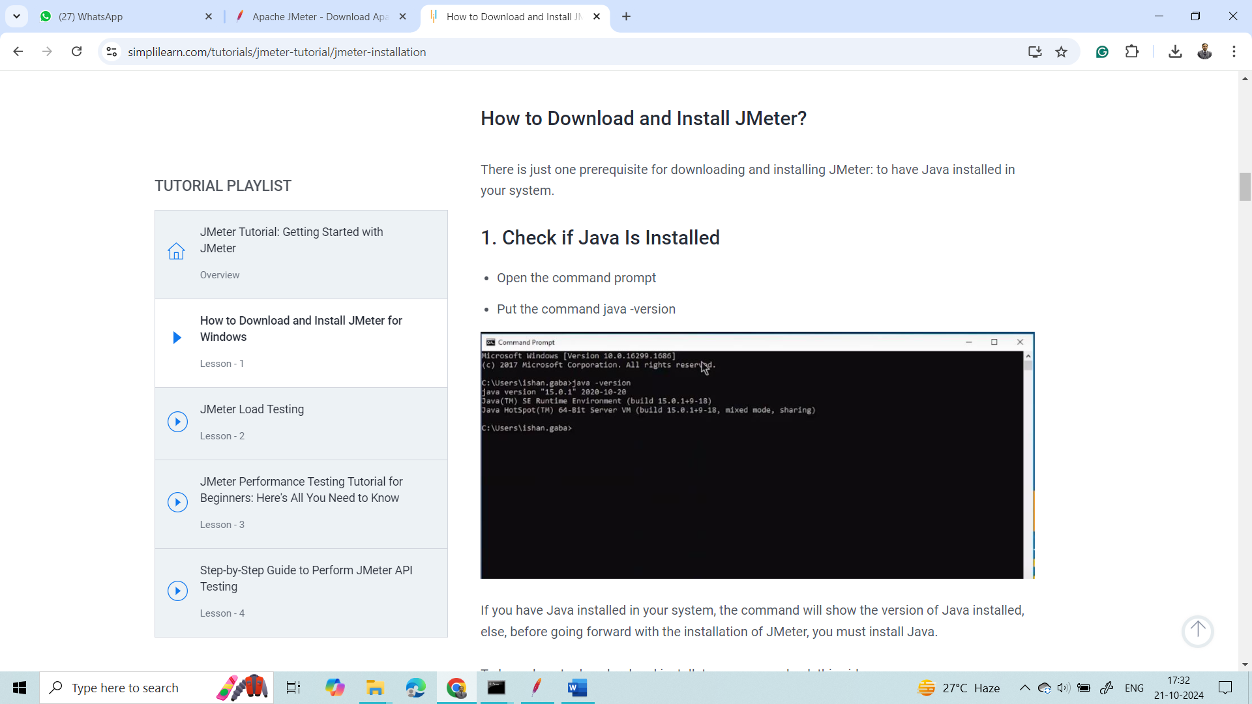

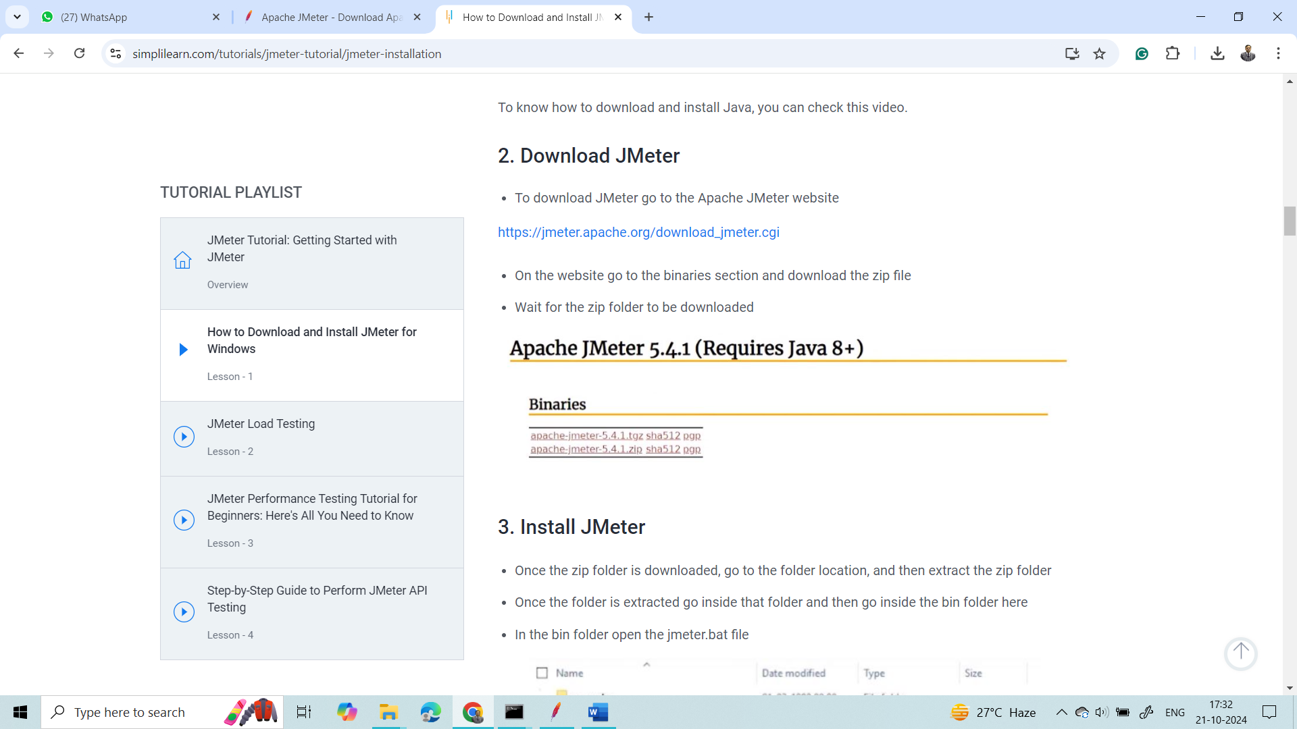

<https://jmeter.apache.org/download_jmeter.cgi>



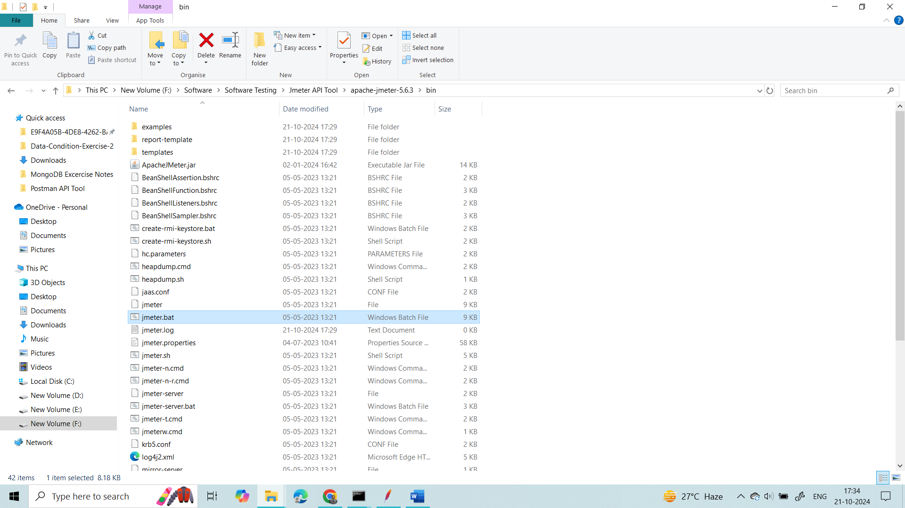

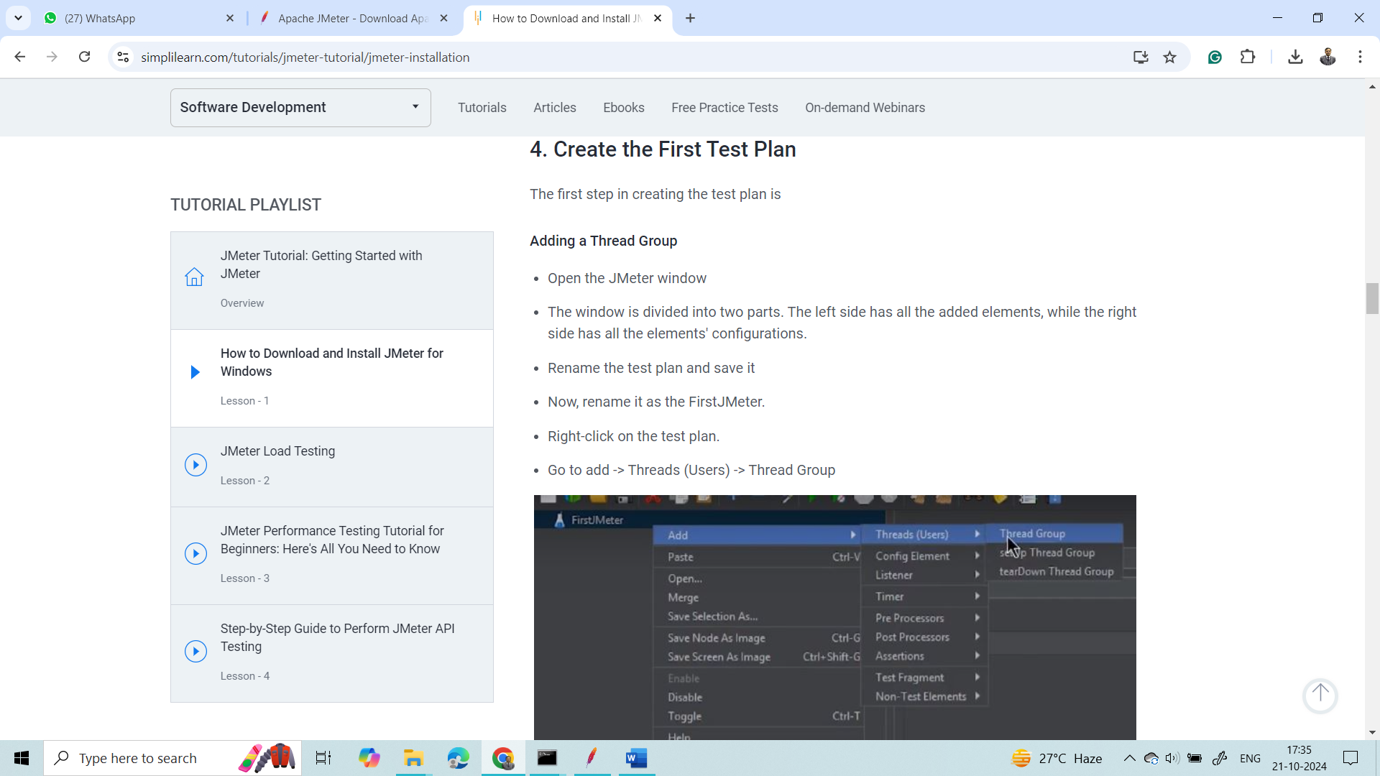

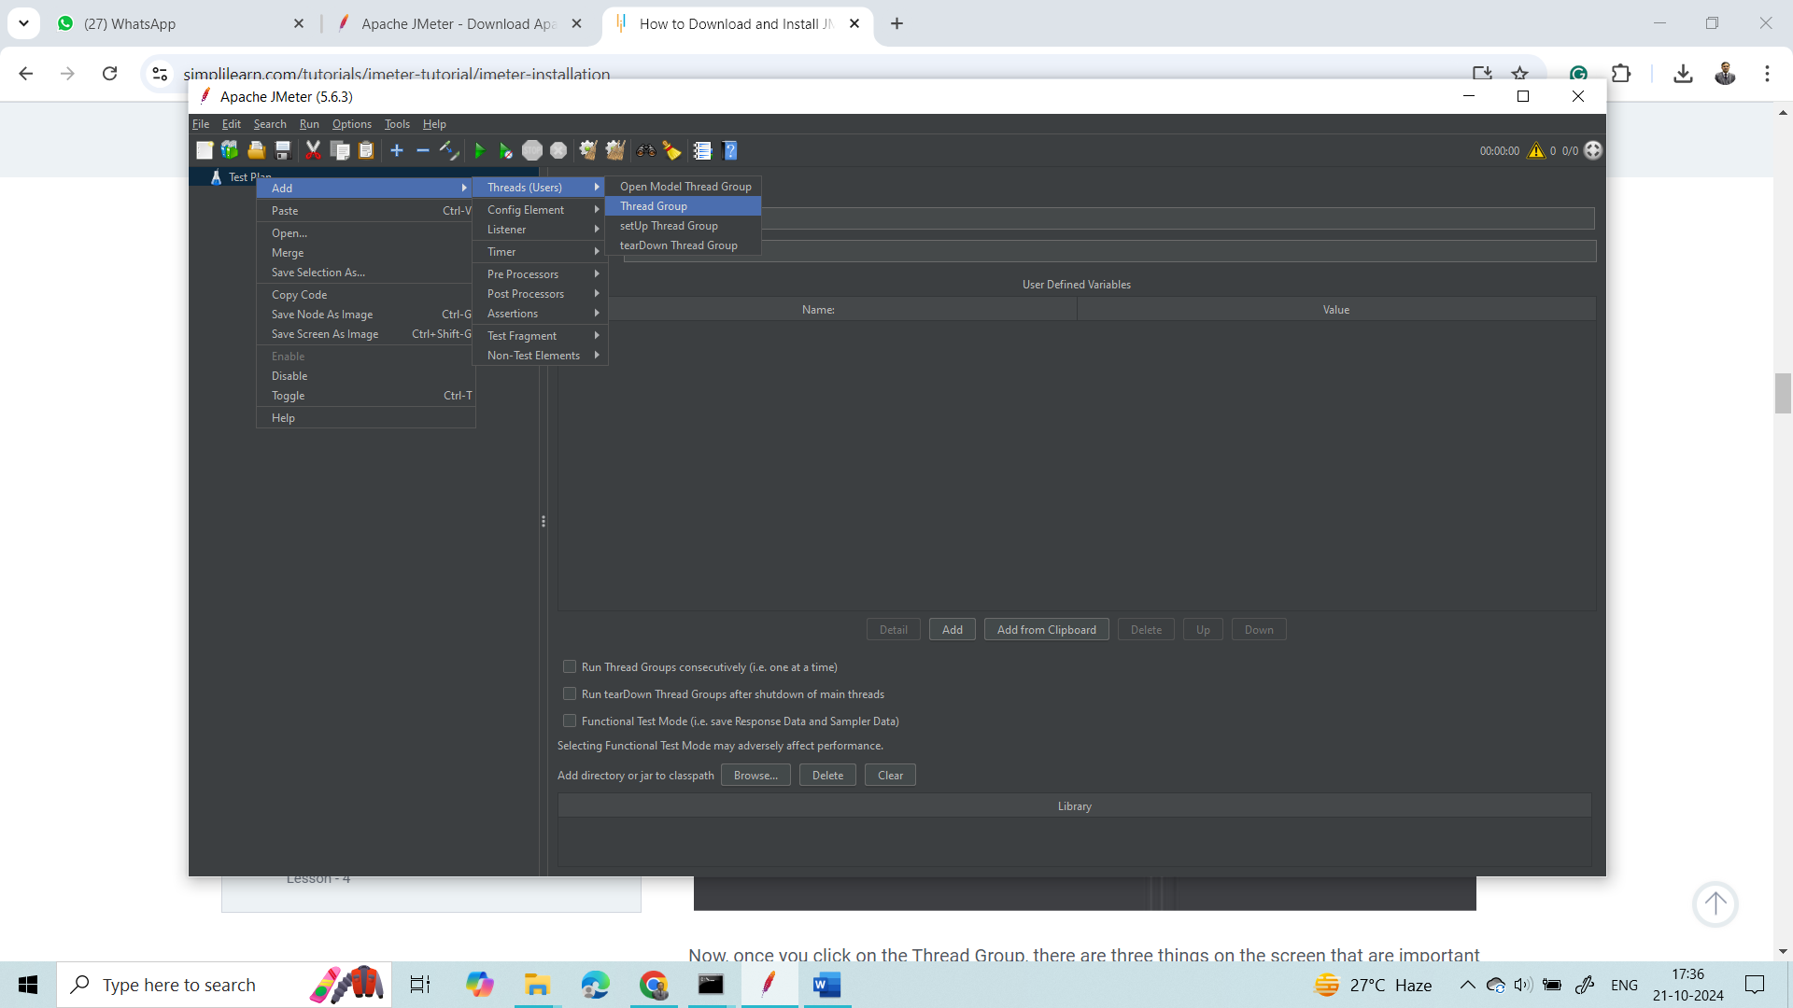

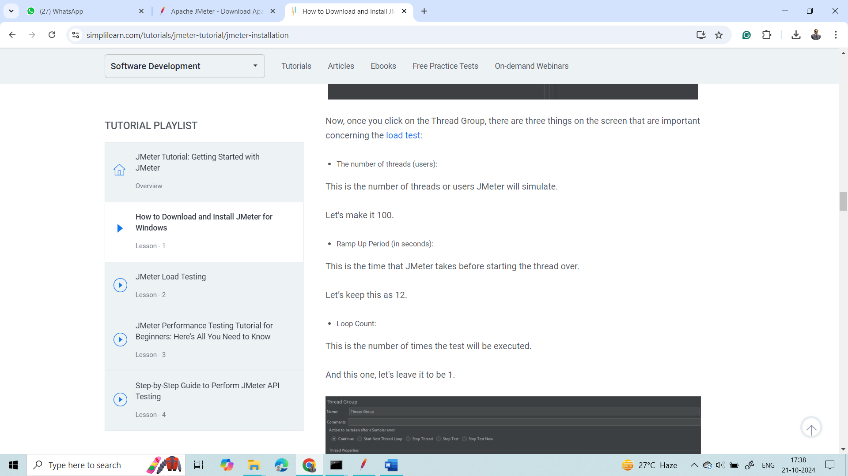

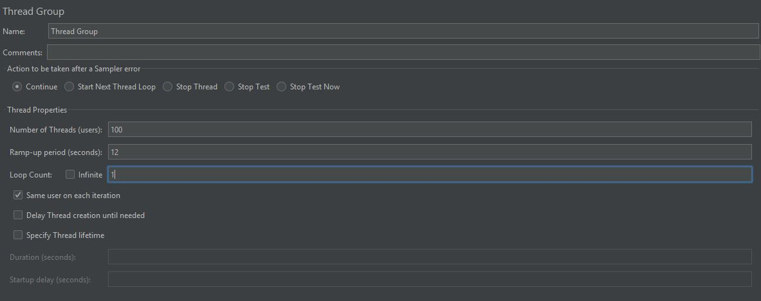

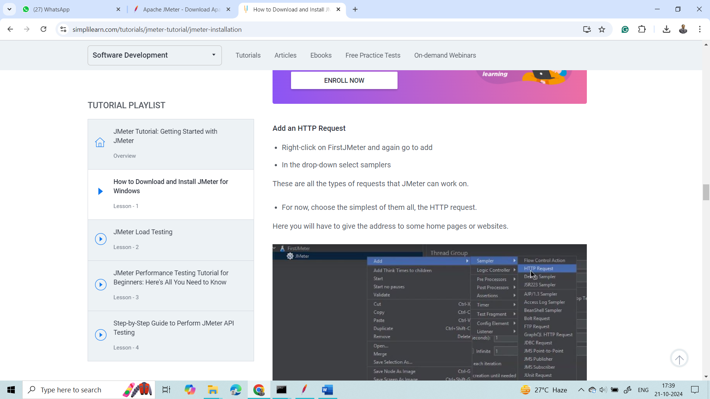

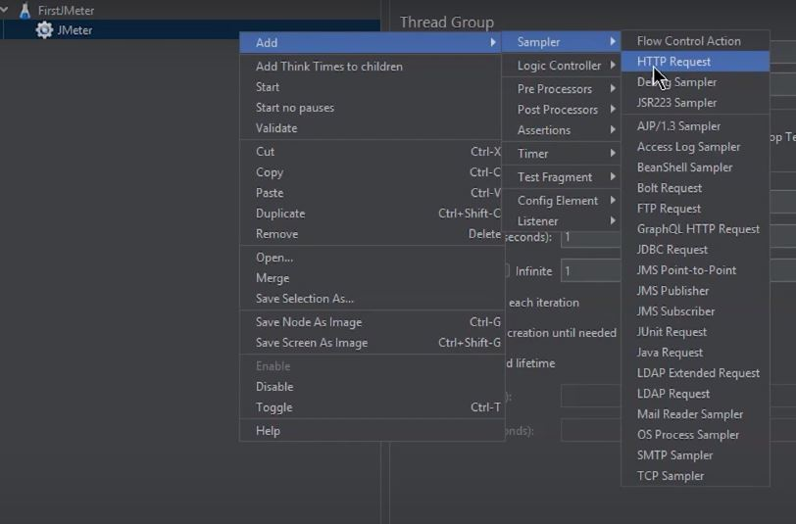

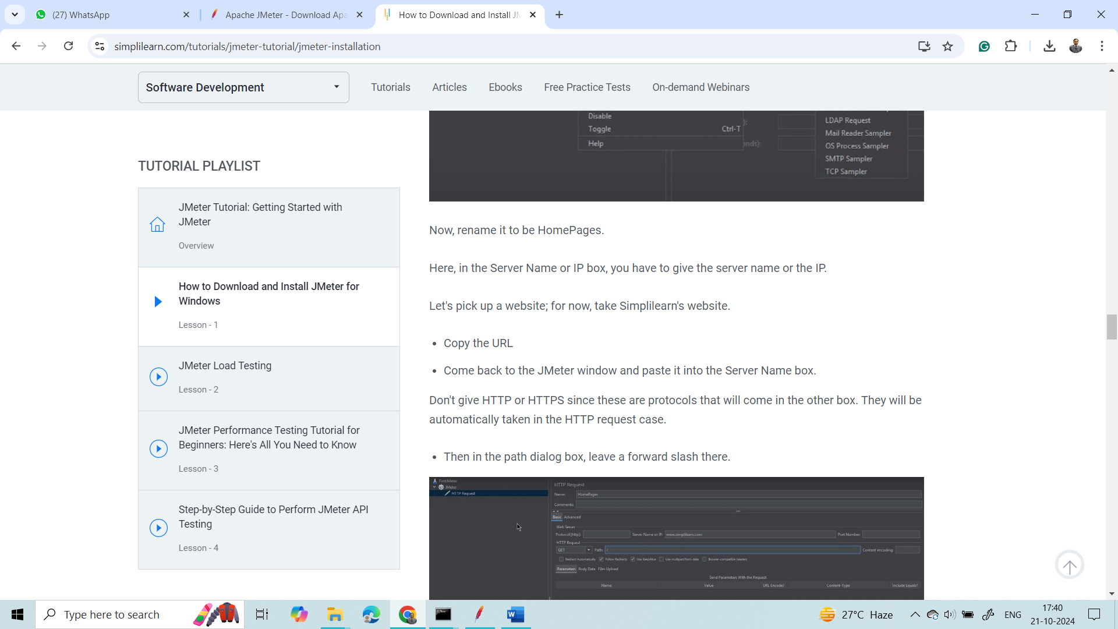

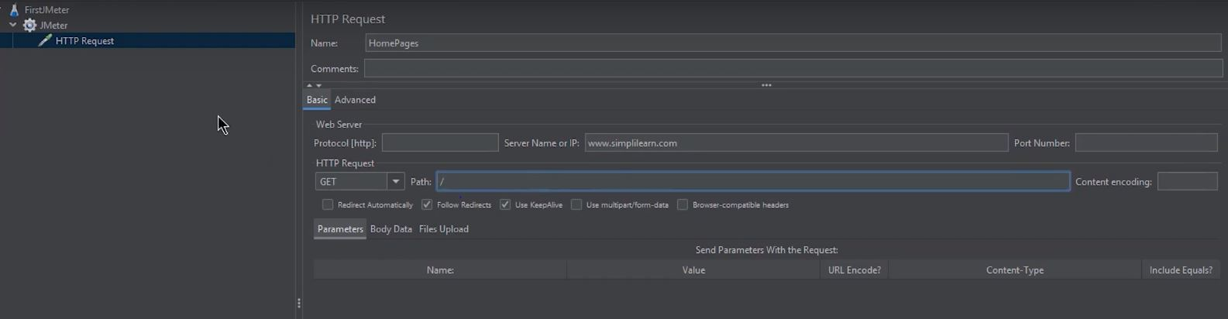

Add Listeners

To determine what the results of the test will be, you need to add some more test elements.

* Right-click on FirstJMeter
* Go to listener options

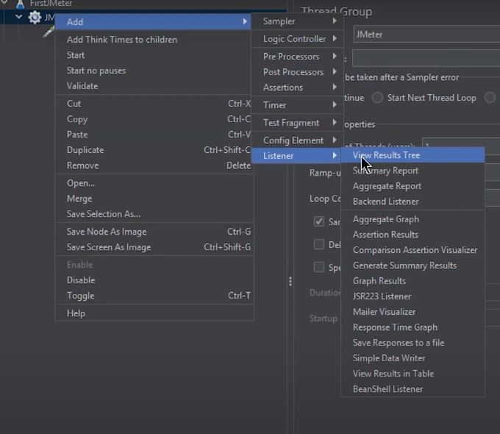

In the box that appears, there are different types of reports that JMeter provides.

For now, select the two of these:

* View results in table
* View results tree

Run the test

* Now, save the test and run it
* For running the test, click the green button
* Now, check the results of the test
* Go to view results in table

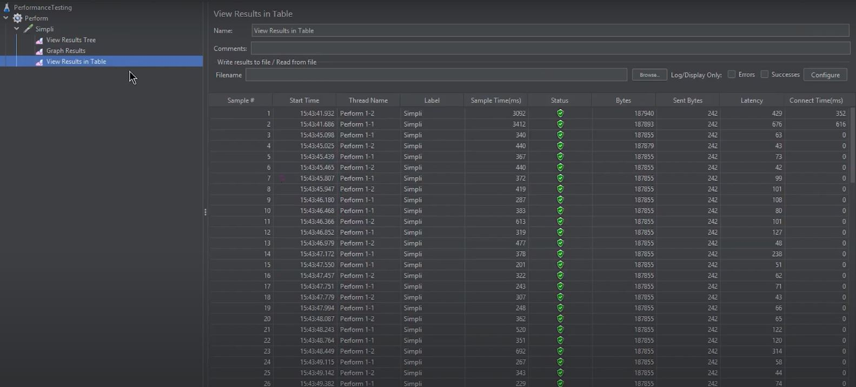

You can see the green status that shows that the test was successful. The label name: FirstJMeter and the sample time can be seen.

* Then check “view results in a tree”

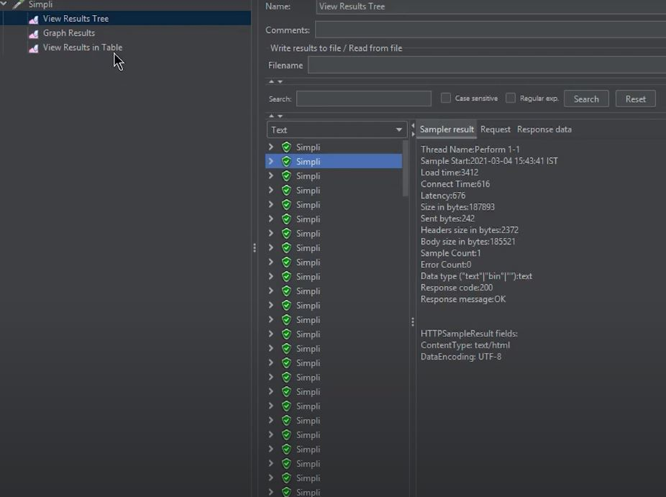

The green status or the success status can be seen here as well.

The test will be performed concerning the number of users, the ramp-up period, and the loop count set up in the first step.

Hence, here on the screen, it is evident that the test is still running. The time is taken, the number of tests being performed, and the status of each hit onto the Simplilearn website can be seen.

And this is how performance testing is performed with the help of JMeter.

**Conclusion**

By now, you would have learned what JMeter is, and how you can install JMeter on your system. You would have understood the entire process to download and install JMeter with the help of a hands-on demo. Furthermore, you would now be able to run a test in JMeter and perform performance testing.

For more information on how to download and install JMeter, you can watch [this](https://youtu.be/AuM11JvEsWU) video.

If you have any questions for us, let us know in the comments section of the “How to download and install JUnit” tutorial. Our experts will answer them for you, at the earliest.